MIS-350: Business Intelligence and Reporting

Professor DeLucia

Ashley Rios

August 12, 2023

**Employee Attrition: Report and Executive Summary**

**Enterprise-Level Report: Introduction**

For this report, the analysis will focus on factors that lead to employee attrition in ABC Company. After analyzing the Excel data, there are many insights that can be gained. Several factors can lead to employee attrition, such as income or distance traveled from home to work. This report aims to identify the potential key factors that have led to employee attrition in this organization.

**Business Questions and Making Sense of Data**

The primary business question that this report is eager to answer is what factors lead to employee attrition. After downloading the Excel file from IBM Watson that includes the employee attrition data, several columns were identified as possible indicators of employee attrition. Information such as department, education, job satisfaction, income, job role, and years at the company and in their current role are all possible factors that could lead to employee attrition.

After the information was loaded into Excel and looked over for completeness, the file was loaded into PowerBI for further data cleaning and transformation. Once the columns were organized and classified into proper data types and categories, I chose which areas the report should focus on. By creating separate tables for job department, education field, employee income, job satisfaction, gender, and job role, I was able to create visualizations to answer questions such as, ‘which department had the highest attrition?’ or ‘what is the difference between an employee’s monthly rate and their actual monthly income, and is there a correlation between this data and employee attrition?’

**Business Intelligence**

PowerBI is a valuable resource in regards to analyzing data and creating actionable insights. By importing the data into PowerBI, I was able to use one Excel file to create multiple tables connected by relationships and linking back to the original table. Using these tables, I was able to go into Report View and create a variety of harmonious visuals that related to each other to show relevant information such as trends or observations regarding employee attrition. These aesthetically-pleasing visuals appeal to the user or viewer, as the colors all coordinate and enrich the visuals without being distracting. The colorful text in some areas, such as the information card in the Department visual, brings the users focus to those insights while also not overpowering the dashboard as a whole.

**Guiding Questions**

After the initial review of the provided data for employee attrition for ABC Company, several business questions arose. This includes questions such as, ‘how many overall employees for the organization left due to attrition? How many were excluded from that category?’ Other questions that were developed include, ‘what was the job satisfaction rating among employees who left due to attrition? Are there any warning signs or trends related to attrition and job satisfaction?’ By using PowerBI to create separate tables that have established relationships to the main table that was imported from Excel, I was able to use the visuals to create a dynamic dashboard to show any potential trends (or lack thereof) to stakeholders.

**Visualizations**

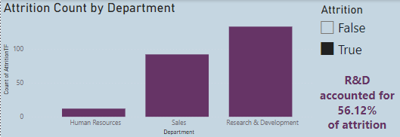

The first visualization on this dashboard is a column chart showing attrition count by department. The visual includes a slider, so that the columns can show the total employees for each department, and can then be separated into those who were categorized ‘yes’ (true) or ‘no’ (false) for attrition. This visual also contains a card highlighting the fact that the Research and Development department accounted for more than half of all employee attrition. The card was created by using the ‘analyze’ option on the column chart and selecting relevant data from the analysis. A slider was chosen so that we are still able to recognize that Research and Development is the largest department overall, which is why it is understandable that it accounts for the most attrition.

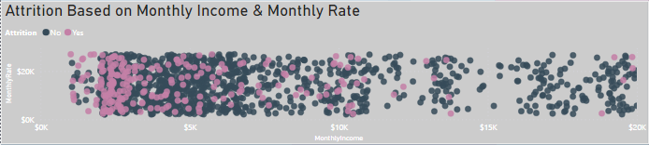

The next visual in the report is a scatter plot showing attrition based on monthly income and monthly rate. This is the largest visual, because there is such a large range of income among employees. This visual shows all employees whether they were marked ‘yes’ or ‘no’ for attrition, but the two colors separate the two choices. This was done so that trends could be recognized, as there is a large pink (‘yes’ attrition) portion of employees who were given a large monthly pay rate, but took home a significantly smaller income. There are a lot of blue (‘no’ attrition) employees in that area as well, which could mean this is a strong factor for attrition and something to be aware of.

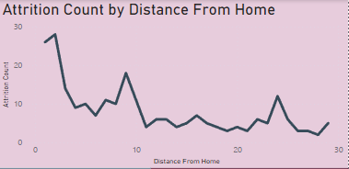

Another visual in this report is a line graph showing the amount of employee attrition based on the distance from home each employee traveled for work. While there are some outlier areas such as those employees that live around 25 miles away, most employee attrition occurred with employees who lived less than 10 miles away.

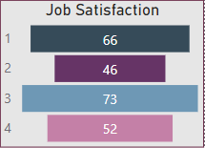

The next visual on the dashboard is a funnel chart showing job satisfaction ratings among those employees marked yes for attrition. A score of 3 out of 4 was the most common rating among those employees, with a rating of 1 coming in second. Employee attrition can occur in several ways, such as employees retiring or quitting and not being replaced. An analysis that could be made from this visual is that employees who quit might have given a rating of 1, whereas employees who retired could have given a higher rating of 3 or 4. Further analysis could include looking at employees who are still employed, to determine any potential risks for quitting due to lack of job satisfaction.

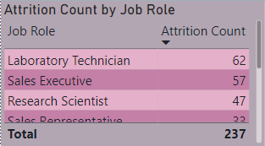

This table shows each role in the organization and their attrition count. The table can be sorted by job role or attrition count, which makes analysis simpler. By sorting the table by descending attrition count, we can see that laboratory technician is the role with the highest amount of attrition. This table is also interactive with the other visuals, so selecting a job role will change the other visuals to show the coordinating data such as education field, gender, or job satisfaction. I chose to use a table for this information because there were several job roles and I prefer not to be repetitive with column and bar charts.

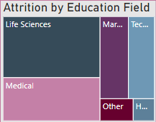

Attrition by education field is shown in a tree map, as there were several fields and the visual is still readable and understandable at a small size, which was needed to arrange the dashboard appropriately. Showing attrition as it is related to education field is another way to determine trends in overall employee attrition. As shown in the visual, Life Sciences is the education field with the highest amount of attrition. When the user hovers the mouse over the life sciences section, it shows that 89 of the total 237 employees marked ‘yes’ for attrition belong to that education field. Selecting an education field will also influence the other visuals, for example if selecting the Medical field, the job role table will adjust the job roles and attrition counts to only show those employees in that education field.

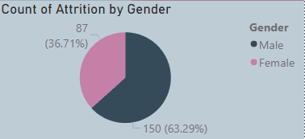

The final visual used is a pie chart to show the attrition count by gender. The pie chart also shows the percentage each gender accounted for. As with the other visuals, as the user interacts with the dashboard as a whole and will adjust the other visuals to show the related information, depending on which gender is selected. I chose to display this information in a pie chart because there were only two options given for this data, meaning a pie chart would be simple and can be looked at quickly to gain insights.

**Actionable Insights**

Based on the analysis and visuals created from the provided data, there are several actionable insights that can be recognized. First, which is also shown on a card, is that research and development accounted for more than half of employee attrition, and also accounts for more than half of the employees overall. Also, we can see that men account for about 63% of employee attrition. From the scatter chart showing monthly income and monthly rate differences, we can realize that a lower income has a strong impact on employee attrition, especially as one highlights individual points on the graph and understands that the rate-to-income difference for some employees was largely significant and fairly common. This could be a prominent factor in employee attrition and should be examined closer if possible.

**Executive Summary**

There are many factors at play when an organization is planning an expansion. Using business intelligence such as PowerBI to create reports can help provide further insight into demanding business questions such as, ‘what are the factors for employee attrition in our organization?’ By evaluating the key findings from the following data visualization analysis, this report aims to answer this business question and relevant follow-up questions in regards to ABC Company and its impending expansion.

After reviewing the data and subsequent visualization, several insights can be made from the resulting information. To create this report, the data was loaded into PowerBI and evaluated for any inconsistencies or errors. Then, the data was cleaned and transformed to properly reflect any data types such as currency. Another column was also created in the table that assigned the yes/no values for employee attrition to true or false statements. By creating reference tables that contained relevant columns such as job department, job role, education field, and job satisfaction, the data was able to be converted into visualizations. The first trends that can be recognized from the visualization is that the Research and Development department accounts for more than half of employee attrition, and men account for more than 60% of attrition when compared to women. Another important trend is that many employees whose departure was attributed to attrition had significant differences in their projected monthly rate and their actual monthly income. While there may be reasonable explanations for this insight, it is something that should be reviewed and hopefully explained or corrected. Another insight is that employees who left by attrition tended to rate their job satisfaction at a 1 or a 3, with 3 being given slightly more often. Reviewing current employees’ job satisfaction and identifying those with low ratings may give more insight into future attrition.

Several questions can be answered from interacting with the data visualization. Each visual can affect the others, which can help to gain further insight into the factors that lead to employee attrition. For example, by highlighting the ‘1’ rating on the job satisfaction visual, it adjusts the other visuals to show that primarily male employees gave this rating, and that laboratory technician job roles and the R&D department gave that low rating. A low rating was also associated with a lower income. Insights such as this can help to potentially identify problem areas in the company that need to be addressed before expansion in order to best reduce employee attrition.